Epidemiological modelling

Contents
[hide]
- 1 Question
- 2 Answer
- 3 Rationale
  - 3.1 Computation
  - 3.2 Data
  - 3.3 Initiate functions
- 4 See also
- 5 References
- 6 Comment the content

Question
How to predict the net effectiveness of pneumococcal conjugate vaccination with a given set of serotypes when the vaccine is included in the national immunisation programme?
- The focus is on the incidence of invasive pneumococcal disease (IPD) cases in different age groups covering the whole population.
- The model is assumed to be valid in a population in which pneumococcal conjugate vaccination of infants has been in place for several years so that a new steady-state after vaccination has been reached.
- The coverage of vaccination and vaccine efficacy against carriage are assumed to be high enough to justify the assumption of complete elimination of vaccine-type carriage among both the vaccinated and also, due to substantial herd effects, among the unvaccinated members of the population.
- Vaccine-type carriage will be completely replaced by carriage of the non-vaccine types whose disease causing potential is not altered by vaccination.

Answer
The predicted reduction in the incidence of invasive pneumococcal disease (IPD) in different age groups are obtained from the serotype replacement model (Nurhonen and Auranen, 2014).

Rationale
The epidemiological model for pneumococcal carriage and disease is based on the assumption that vaccination completely eliminates vaccine-type carriage in the vaccinated population and that vaccine-type carriage is completely replaced by non-vaccine-type carriage. The implications of this replacement on the decrease or increase in pneumococcal disease then depend on the disease causing potential of the replacing types compared to that of the replaced types. To predict the incidence of post-vaccination disease only pre-vaccination data on serotype-specific carriage and disease are used.
The consequences of serotype replacement in the model depend on two key assumptions regarding the new steady-state after vaccination:
- the relative serotype proportions among the non-vaccine types are not affected by vaccination (proportionality assumption);
- the case-to-carrier ratios (the disease causing potentials) of individual serotypes remain at their pre-vaccination levels.
The implications of vaccination on disease incidence are assumed to be solely due to the elimination of vaccine type carriage and its replacement by non vaccine-type carriage. An exception to this is when protective efficacy against disease without any efficacy against carriage is assumed for certain serotypes (a feature to be added).
The replacement model was built to reflect the accumulated 15 year long experience on use of pneumococcal conjugate vaccines worldwide and the related scientific research activity. Some of the most recent relevant publications are listed on a separate page: References.

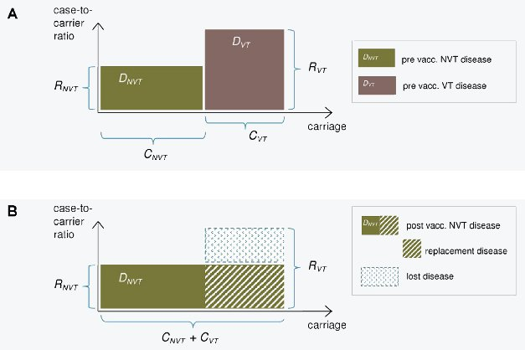
Figure 1. Illustration of the replacement model. The incidence of pneumococcal carriage (x-axis) and case-to-carrier ratios (y-axis) for vaccine serotypes (VT) and non-vaccine serotypes (NVT) before (panel A) and after vaccination (panel B). The incidences of disease (DVT and DNVT) are obtained by multiplication of the two quantities and correspond to the areas of the rectangles. After vaccination, VT carriage is eliminated and replaced by NVT carriage (panel B). The decrease in IPD incidence after vaccination is obtained as the difference between the eliminated VT disease and the replacing NVT disease. This is the area of the blue rectangle in panel B.

Computation
The following program illustrates the working of the replacement model. In its current implementation the code allows the user to specify 4 vaccine compositions and then displays the predicted number of IPD cases in Finland per year corresponding to these vaccines. The results are shown by serotype and by age category (<5 and 5+ year olds). Possible choices for vaccine compositions are: PCV10, PCV13, no vaccination and a user specified serotype composition. The program is based on the code in File S1 of Nurhonen and Auranen, 2014.
Instructions for user: Choose the desired vaccine compositions from the list below and then press "Run code".
You can compare 2,3 or 4 vaccine compositions. The results will be displayed on a separate tab. The default choice is PCV10 and PCV13.
Scenarios
Please choose the vaccines to be compared::
PCV-10
PCV-13
No vaccination
Do you want to specify another vaccine composition?:

+ Show code

Data
[hide]Show details
Serotypes in typical pneumococcal vaccines(-)
Obs | Vaccine | Serotype
1 | PCV10 | 19F
2 | PCV10 | 23F
3 | PCV10 | 6B
4 | PCV10 | 14
5 | PCV10 | 9V
6 | PCV10 | 4
7 | PCV10 | 18C
8 | PCV10 | 1
9 | PCV10 | 7
10 | PCV13 | 19F
11 | PCV13 | 23F
12 | PCV13 | 6B
13 | PCV13 | 14
14 | PCV13 | 9V
15 | PCV13 | 4
16 | PCV13 | 18C
17 | PCV13 | 1
18 | PCV13 | 7
19 | PCV13 | 3
20 | PCV13 | 6A
21 | PCV13 | 19A
22 | Existing serotypes | 19F
23 | Existing serotypes | 23F
24 | Existing serotypes | 6B
25 | Existing serotypes | 14
26 | Existing serotypes | 9V
27 | Existing serotypes | 4
28 | Existing serotypes | 18C
29 | Existing serotypes | 1
30 | Existing serotypes | 7
31 | Existing serotypes | 6A
32 | Existing serotypes | 19A
33 | Existing serotypes | 3
34 | Existing serotypes | 8
35 | Existing serotypes | 9N
36 | Existing serotypes | 10
37 | Existing serotypes | 11
38 | Existing serotypes | 12
39 | Existing serotypes | 15
40 | Existing serotypes | 16
41 | Existing serotypes | 20
42 | Existing serotypes | 22
43 | Existing serotypes | 23A
44 | Existing serotypes | 33
45 | Existing serotypes | 35
46 | Existing serotypes | 38
47 | Existing serotypes | 6C

Initiate functions

+ Show code

See also
Tendering process for pneumococcal conjugate vaccine
Parts of the assessment | Comparison criteria for vaccine · Epidemiological modelling · Economic evaluation
Background information | Replacement · Pneumococcal vaccine products · Finnish vaccination schedule · Selected recent publications  Help for discussion and wiki editing
Pages in Finnish | Pneumokokkirokotteen hankinta · Rokotteen vertailuperusteet · Epidemiologinen malli · Taloudellinen arviointi · Pneumokokkirokotteen turvallisuus  Work scheduling · Monitoring the effectiveness of the pneumococcal conjugate vaccine · Glossary of vaccine terminology

References
Nurhonen M, Auranen K (2014) Optimal Serotype Compositions for Pneumococcal Conjugate Vaccination under Serotype Replacement. PLoS Comput Biol 10(2): e1003477. doi:10.1371/journal.pcbi.1003477

