Authors
Jouni T. Tuomisto1*, Marjo Niittynen1, Erkki Pärjälä2, Arja Asikainen1,2, Laura Perez3, Stephan Trüeb3, Matti Jantunen1, Nino Künzli3, Clive Sabel4
- Department of Environmental Health, National Institute for Health and Welfare, P.O.Box 95, FI-70701 Kuopio, Finland
- City of Kuopio, P.O.Box 228, 70101 Kuopio, Finland
- Swiss Tropical and Public Health Institute, Socinstrasse 57, 4002 Basel, Switzerland
- School of Geographical Sciences, University of Bristol, Senate House, Tyndall Avenue, Bristol, BS8 1TH, United Kingdom

* Corresponding author: Jouni Tuomisto: jouni.tuomisto(at)thl.fi), phone +358 29 524 6305
Marjo Niittynen: marjo.niittynen(at)thl.fi. Erkki Pärjälä: erkki.parjala(at)kuopio.fi. Arja Asikainen: arja.asikainen(at)thl.fi. Laura Perez: l.perez(at)unibas.ch. Stephan Trüeb: stephan.trueeb(at)bl.ch. Matti Jantunen: matti.jantunen(at)janding.fi. Nino Künzli: nino.kuenzli(at)unibas.ch. Clive Sabel: c.sabel(at)bristol.ac.uk.
Title

Building-related health impacts in European and Chinese cities – scalable assessment method

Abstract
Climate change mitigation requires intensive actions to minimise greenhouse gas emissions in the future. Many of these actions are taken place in cities due to their traffic, buildings, and energy consumption. However, these climate policies also have other impacts, which may be beneficial or harmful. In this work we especially looked at health impacts of climate policies in cities related to heat and power consumption of buildings.
Our objective was to develop a generic open impact model that can be used on city level with city-specific data and that can be used for policy comparison. The key part of the model is a module to calculate the size and properties of the building stock in time.
We demonstrated the functionality of the model by applying it to two case cities of the EU funded project URGENCHE, namely Kuopio and Basel. We estimated the climate and health impacts of actual policies planned or implemented in the cities.
Renovation policies to improve the energy efficiency of buildings can reduce greenhouse gas emissions significantly, but this requires systematic policy for decades. In contrast, fuel changes in large district heating facilities may have rapid and large impacts on emissions. However, the life cycle impacts of different fuels is somewhat an open question. The latter policy had minor impacts on health, because the harmful PM2.5 emissions from district heating are already low.
In conclusion, we were able to develop a model for city-level assessment that have practical use in policy support. Although all data and code is freely available, implementation of the current model version in a new city requires modelling skills.
Keywords:
Climate change, building stock, cities, policy support, health impact assessment, heating, city-level decision making, fine particles

Introduction
Climate change is the major environmental concern of our time. Cities contribute significantly to the overall greenhouse gas (GHG) emissions as most of the traffic, industry, commerce and more than 50% of world´s population are located in urban areas. EU FP7 funded project URGENCHE studied the health impacts of climate policies in two cities in China (Suzhou and Xi’an) and 5 cities in Europe (Basel, Kuopio, Rotterdam, Stuttgart and Thessaloniki). The main study areas included heat and power generation, traffic, buildings and their effect on health and well-being. The assessed climate policies for each city were defined and formulated based on the actual climate strategies of the cities.
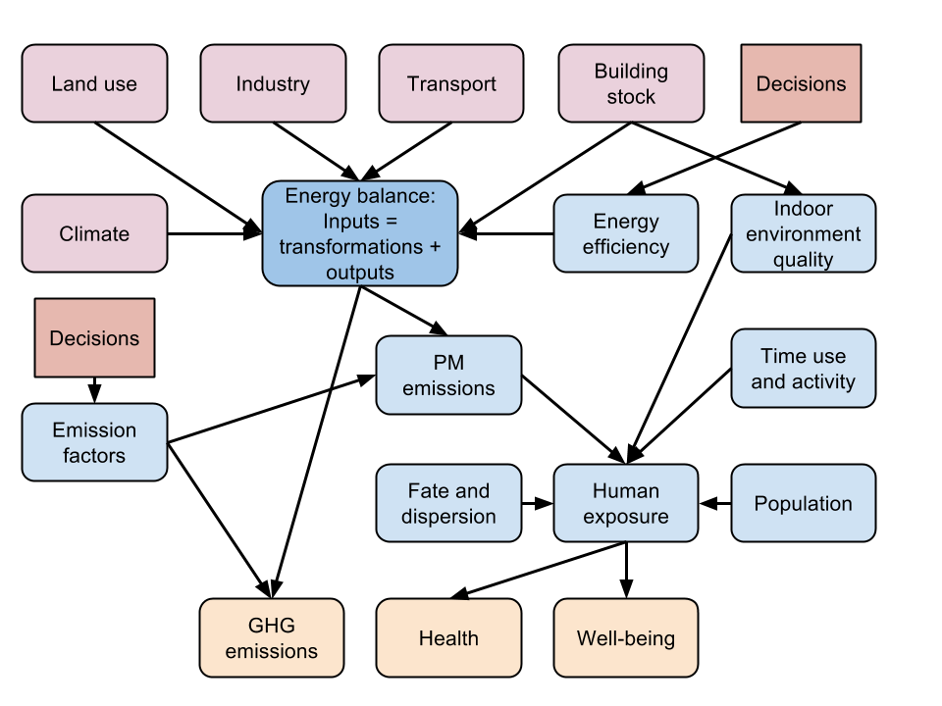
Figure 1. Conceptual model of important factors related to city-level energy balance and buildings. This conceptual model was used to develop the actual computational model focussing on buildings. Driving forces are in pink, outcomes of interest in orange, and decisions to change outcomes in red.
The building stock does not only consume energy, it also most significantly influences health and comfort of the population. In OECD countries 26% of total energy is consumed in residential buildings. ^{[1]} Key determinants for health and comfort in buildings are air quality, dampness, draft and indoor temperature, which are linked to energy efficiency via heating, ventilation, and insulation. Many climate policies aim at reducing the energy consumption of buildings and therefore influence health and comfort of the people. These influences can be positive and/or negative. Positive effects are usually mediated via better indoor air quality and decreased dampness through improvements in ventilation and increased thermal comfort through better insulation. ^{[2]} However, increased insulation may also cause negative effects via reduced air exchange, increased indoor temperature in the summer and increased moisture accumulation in the building structures. The latter applies especially in the cold climate zones, where energy conservation regulations can only be met by thick insulation layer, where leaking indoor air may reach dew point and condense water. Where current insulation is inadequate, however, properly installed additional insulation is an investment which both saves money and improves health and comfort. Monetary savings by insulation can also have equity benefits as they are relevant for subgroups that have difficulties to afford cost of heating.
The critical question of building-related policies is how to reduce GHG emissions and promote health at the same time. The aim of this study was 1) to develop a modelling tool for the assessments of building stock impacts on GHG emissions and various health parameters 2) to apply this tool in the participating URGENCHE cities for dynamic (past and future) projections of the size of building stock, building-related GHG and PM_{2.5} emissions as well as the consequential health effects attributable to buildings. We demonstrate the building model with two policies in Kuopio and in Basel providing estimates of changes in the built space, GHG and PM_{2.5} emissions as well as health effects up to 2050.
The conceptual placement of buildings in relation to energy balance of a city and health of population is shown in Figure 1. In this article, we only corncern the nodes that relate to the node Building stock. Other driving forces (i.e. climate, land use, industry, and transport; in pink) are discussed in other URGENCHE articles.

Materials and Methods

Description of the study cities
The following cities participated in URGENCHE project: Basel (Switzerland), Kuopio (Finland), Rotterdam (Netherlands), Stuttgart (Germany), Thessaloniki (Greece), Suzhou (China), and Xi´an (China). Some basic statistics for each study city are given in Table 1.
Kuopio
Kuopio is the 8th largest city in Finland with a population of 107 500 (2014). It is located in eastern Finland (coordinates 62°53'33"N 027°40'42"E) and the municipality area is 3 165 km². In addition to the compact urban area, where 85% of the population lives, the municipality includes large rural and lake areas. The building stock of Kuopio is heated mainly via a district heating network (88%), by fuel oil (8%) and electricity (4%)(Figure 3). In most detached homes wood is used for supplementary heating, but this is not estimated in this assessment. In total there are 50 000 buildings and 60 000 dwellings in the whole Kuopio. The total GHG emissions were 1.02 Mt CO₂-eq in 2010, out of which 43% was due to heating of buildings (district heating 35%, electric heating 4%, separate heating 4%). The mean annual temperature in Kuopio is 2.7 °C and precipitation about 498 mm (www.kuopio.climatemps.com).
Basel
Basel is the third largest city of Switzerland having population of 195 000 (700 000 in the metropolitan area). It is located in the corner where Switzerland, France and Germany meet (coordinates 47°34'N 7°36'E) and has the land area of 23.91 km². The annual mean temperature is 9 °C and precipitation 791 mm. Total annual GHG emissions were 2.4 Mt CO₂-eq in 2010-2011, out of which combustion makes up 56%, road traffic 26%, and waste management 18%. 100% of electricity used in Basel comes from renewable sources. Residential heating and hot water accounts for 22% of the total energy use in Basel.

Building and energy data
Extensive amount of building and other data was collected about the two cities. Summary tables of the most important data can be found from supporting online material (tables SOM1-1 to SOM1-6). In addition, the very detailed data can be found from these Opasnet pages:
- http://en.opasnet.org/w/Building_stock_in_Kuopio Building stock data in Kuopio
- http://en.opasnet.org/w/Climate_change_policies_and_health_in_Kuopio Policies in Kuopio
- http://en.opasnet.org/w/Building_model Building model (the actual model code)
- http://en.opasnet.org/w/Buildings_in_Basel Building stock data in Basel
- http://en.opasnet.org/w/Climate_change_policies_in_Basel Policies in Basel
- http://en.opasnet.org/w/Energy_use_of_buildings Energy consumption, energy efficiency, and impacts of renovation
- http://en.opasnet.org/w/Emission_factors_for_burning_processes Emission factors
- http://en.opasnet.org/w/HIA Health impact assessment model used to assess health risks based on exposures from the building model.
The building floor area in Kuopio has grown constantly since the 1950's and the trend is assumed to continue. Based on future projections of population growth and housing trends of the area we expect that the construction rate remains the same until 2050.

Assessed policies
Climate policy of Kuopio 2009-2020
Key components of the climate policy of Kuopio are on one hand heat and power cogeneration, which provides 88 % of all space heating and 61 % of all electric power used within the municipality, and on the other hand replacement of the [semi]fossil peat with renewable biomass (Table 2). District heat for the building stock within the 440 km heat distribution network is supplied from from the Haapaniemi 2 and 3 cogenerating stations with respective capacities of 120 MW heat and 60 MW power, and 80 MW heat and 49 MW power. Both apply fluidised bed combustion technologies, which enable flexible use of biofuels, SO₂ removal and low NO_{X} emissions. The prioportion of biofuels has increased from 4% in 2009 to over 50 % in 2014, and, depending on the supply, will continue to increase. Oil fired boilers provide reserve and peak capacity, but generate in average only 2 % of the annual heat demand. The objective of Kuopio´s climate policy is to reducing the fossil GHG emissions from the 1990 to 2020 by 40%. Peat is classified as fossil fuel, with it’s a CO₂ emission factor of 380 kg/MWh, whereas the combustion of wood is assumed to be greenhouse neutral, i.e., its fossil CO₂ emission factor is 0, although its direct CO₂ emission factor is 420 kg/MWh (Table SOM1-6).
Other measures of Kuopio's climate policy include reducing the energy used in public buildings by 9 % and conservation campaigns for the public. In addition the national building codes provide energy conservation incentives and regulations for all new and renovated buildings. In general, the GHG mitigation policies of Kuopio focus mostly on the public utilities and other public measures.
Climate policy of Basel
The ambitious energy policies implemented during these past decades in Basel have resulted in CO₂ emissions lower than the annual 2.4 Mt/cap target of the Federal government. The city of Basel energy policy now revolves around reducing individual consumption and shifting towards renewable energy. The current policies rely on 4 pillars:
- Currently 100% of the electricity used in Basel city originates from renewable sources, 90% hydro, the rest from biomass, solar and wind. District heat for Basel is provided by a 25 MWt wood fired cogenerating station, a connected geothermal plant and a 17.2 MWt waste incineration plant. In addition to energy generation, the regulation also covers thermal insulation, ventilation and air conditioning systems and thermal insulation of the buildings. The canton has some of the strictest insulation regulations in Switzerland. For new construction or existing heating systems renovation, 50% of the energy for hot water must come from renewable sources. In 2008, Basel-City also began a three-year building renovation programme.
- Since 1984, the canton of Basel-City has added a 9% tax on electricity, which is invested into renovation of buildings, promoting renewable energy and energy efficiency, awareness raising and innovation. Although electric power demand has declined continuously since mid 1990’s' the canton of Basel-City added in 1998 a steering tax (Lenkungsabgabe) on electricity. The income from this tax is redistributed at a fixed annual rate to households on a per-capita basis and to companies in relation to to total paid wages.
- The solar energy exchange (Solarstrombörse) guarantees to any local producer of photovoltaic electricity that all the produced electricity can be fed into the grid of the public provider, who pays a price set at a level to fully cover all costs of the producer. These incentives promote the installation of photovoltaic systems.
- The city of Basel promotes the “2000 watt-society” with the objective to reduce the per capita energy use from the current 4000 to 2000 W without sacrificing the quality of life.
Increasing the rate of building renovations is another policy focus in Basel and this was used for URGENCHE scenarios Table 2. In comparison to Kuopio, the GHG mitigation policies of Basel are more focused on incentives targeting individuals, households and businesses.
Policies used in the model
The renovation and fuel change policies of Kuopio and Basel that were tested by the model are shown in Table 2 and the energy conserving potentials of different renovations in Table SOM1-5. The energy conserving and CO₂ reduction potentials of the policies for the Municipality of Kuopio are based on ^{[3]} and for Basel on ^{[4]}.

Model development
We set the following objectives to the building model development: The model should
- reflect important factors of a city building stock needed to quantitatively estimate its heat and power demand,
- have a modular structure so that city-specific data modules can be attached to generic computational modules to create a complete model,
- provide connections to energy balance model and other models to be developed about other driving forces,
- present all the data used as open linked data (i.e. in machine-readable format in the Internet),
- only use open source code and open licenses.
Implementation
The building model developed and tested in this study was structured to include all important parts defined by this conception. Extensive amount of data was collected from the two cities used as examples when constructing the model. These included detailed descriptions of the building stock, i.e., the quantitative information on different building types, their heating system and energy consumption and/or demand (Tables SOM1-1 to SOM1-4.) as well as geographical information on the location of buildings, data on the construction, renovation and dismantling rates as well as the local and national policies concerning buildings and data on the energy conservation potential of different renovations. In addition, data on indoor environment quality (IEQ) factors, such as ventilation, heat/cold, dampness, biomass burning, radon, smoking, space and neighborhood, were collected.
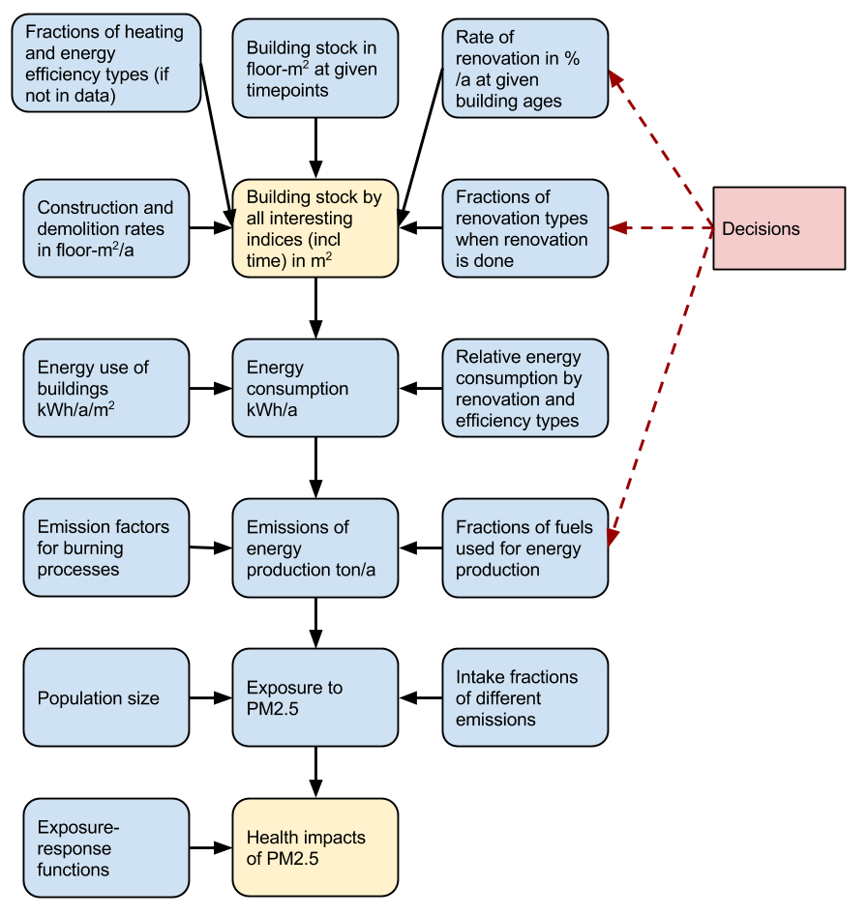
Figure 2. The actual modules of the computational model. The upstream modules contain city-specific building data, and the model becomes increasingly generic in the downstream. Health impact module is actually another generic Opasnet model that is compatible with the building model and uses its outputs as inputs.
The building model for city assessments was developed and can be found in Opasnet (http://en.opasnet.org/w/Building_model), which is an online workspace e.g. for impact assessments and other decision support.
Each module has one of the two essential parts: a data table containing information about the key property of that module, or a formula that can be used to compute such a data table. A key property may be e.g. the building stock amount in floor-m²), and this is further specified by indices defining the conditions when a particular value applies. For example, the floor area may have indices Time (time of observation), Built (time when the building was built), City_area (location on the building), Building (type of the building), and Heating (heating system used in the building). Some of the indices are always necessary in the building model, but in a specific city case the user may use additional indices without any change in the model code (however, there is a cost in computing time). The data may be on individual building level, or it may be aggregated, as long as the data table columns remain the same.
Because of the modular structure, the user can replace any of the city-specific building data modules with data from another city as long as the core structure and unit of the module stays the same. This can be implemented in Opasnet e.g. by creating a new city-specific page that calls the city-specific data tables from the database and then runs the generic model. An interested user can get a user account to Opasnet and then create such a page for her own purposes.
An important functionality of the model is that the core model contains no policies but the user can define policies outside the model. When the model is run, the code automatically checks whether there are policies defined. If there are, each policy option is run as a scenario and propagated through the model. A policy is shown in the output as an index, and the different values of the index differentiate the different options. The defining of policies can be done e.g. as a table on the case-specific wiki page (the user needs to know wiki editing), or a user-friendly interface can be built so that the user can define the actual policies using drop-down menus or entry boxes (the user needs no technical skills). The relationships between the modules are deterministic, but if the inputs are given with uncertainties, the uncertainties are propagated through the model using Monte Carlo simulation and the outputs are probability distributions.
Operation
The case studies about Kuopio and Basel were performed in Opasnet. The case-specific data, models, and user interfaces are available at http://en.opasnet.org/w/Climate_change_policies_and_health_in_Kuopio and http://en.opasnet.org/w/Climate_change_policies_in_Basel, respectively. In the next chapter, we will show the main results of these two cities and discuss the other Urgenche cities where no quantitative modelling was done.
If the user just wants to reproduce the case study results, she can go with a web browser to the respective page to subheading Model and click Run code. If she wants to modify the code, she can click Show code and copy the whole code to R on her own computer. The newest version of R is recommended (3.1.2).
The user interface of the model is a wiki (www.mediawiki.org). The data was stored in a MongoDB (www.mongodb.org) No-SQL database and the actual model code was written in R (www.cran.r-project.org version 3.1.2). The model requires OpasnetUtils and ggplot2 packages, which are freely available at the CRAN repository. All data and module downloads happen automatically when online. All code and data was released using the Creative Commons Attribute - Share alike 3.0 license.

Assessment results

Kuopio
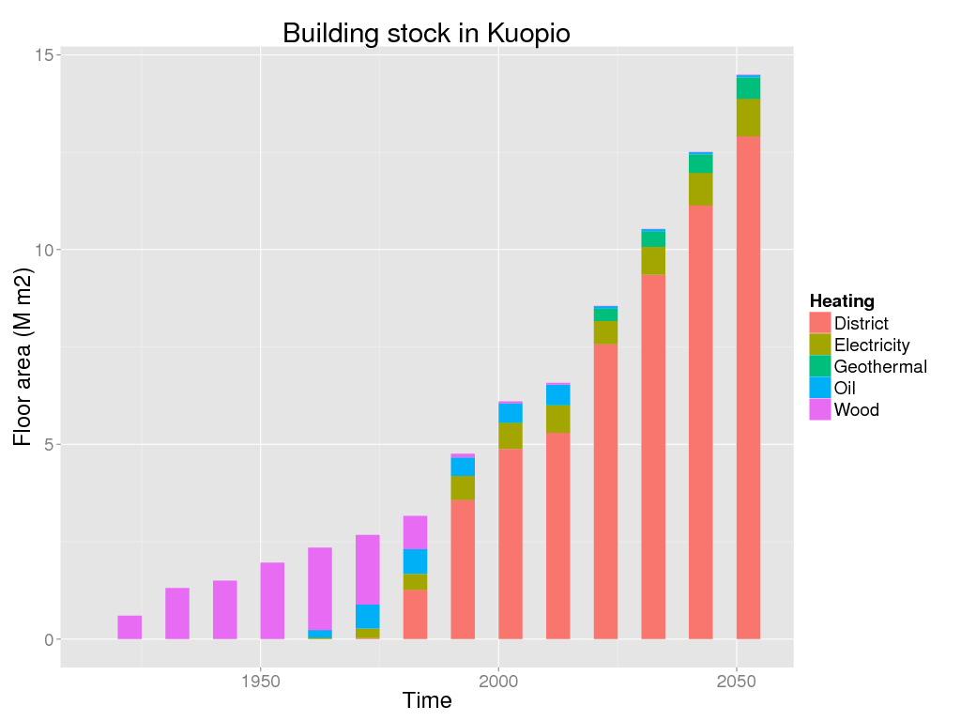
Figure 3. Building stock in Kuopio by heating type.
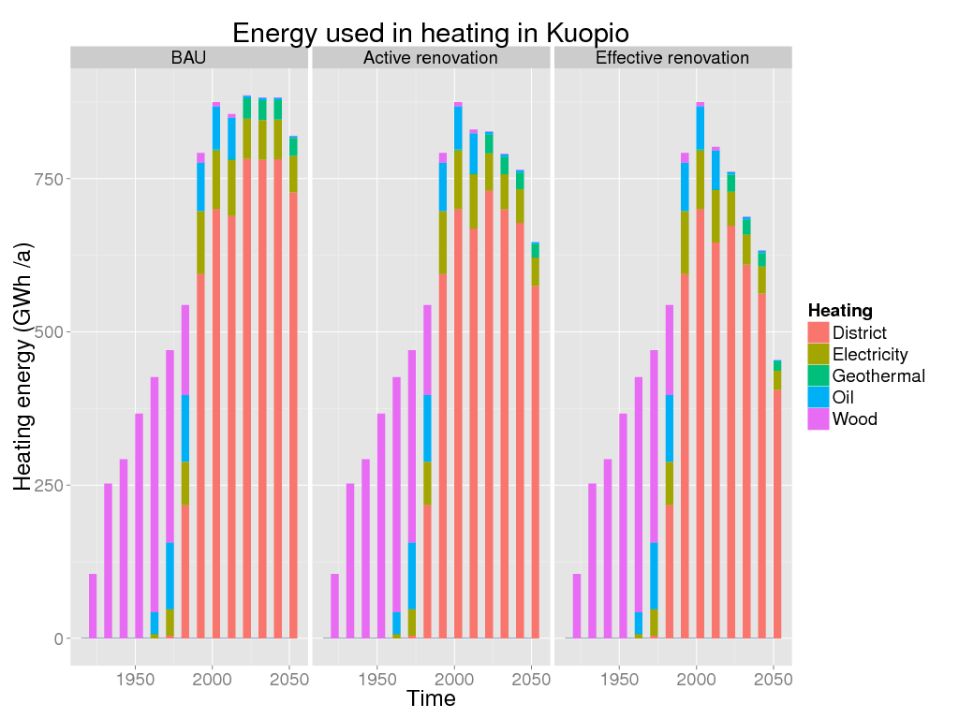
Figure 4. Heating energy used in Kuopio by heating type and renovation policy. Left panel is business as usual (3%/a renovations), middle panel is active renovation (4.5 %/a renovations), and right panel is efficient renovation (3 %/a, sheath reform to all).
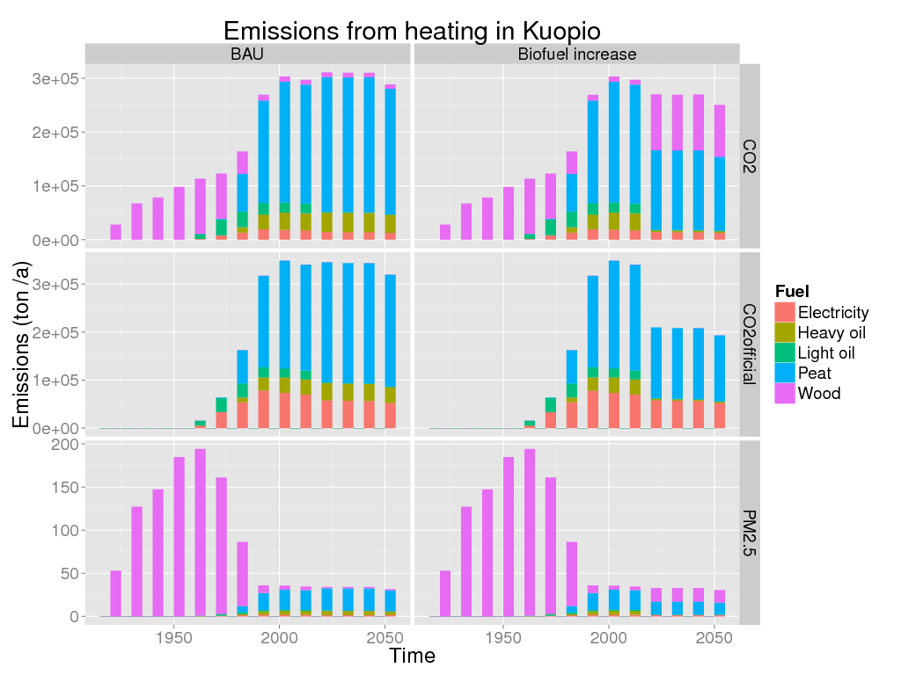
Figure 5. Emissions from heating in Kuopio by fuel type: estimated history and predictions 1920-2050. Left panels are for BAU, right panels are for biofuel policy. CO₂ official (middle horizontal panel) assumes that biofuel emissions are carbon neutral. Secondary wood heating is missing from the estimates although it is a substantial proportion of the current exposure.
The development of the building stock in Kuopio is shown in Figure 3. There was a large shift from single-house wood heating to district heating between 1960 and 1985. Also the typically two-floor wooden house city centre was largely replaced by 6-floor apartment buildings during that period.
The BAU rate of renovating 3% of the building stock per year would mean that on year 2050 almost two thirds of the built space in Kuopio could be considered energy efficient according to 2010 requirements. The more ambitious active renovation policy of 4.5 %/a would increase the proportion of improved energy efficiency to almost 100 % of the total indoor space. The higher renovation rate reflects the upper limit of technical rather than economical feasibility.
The BAU renovation policy would keep the heat demand of the building stock in Kuopio nearly constant in around 800 GWh/year between 2010 and 2050, as the increased volume would cancel out the increased energy efficiency (Figure 4.). The active renovation policy would reduce the heat demand by around 30 % in spite of the prognosed doubling of the building stock; this could be further enhanced with tightening building regulations.
Due to the biofuel policy, the fossil CO₂ emissions attributable to buildings would be reduced by more than 30% but respective PM_{2.5} emissions would change clearly less from the 2010 level by 2020 (Figure 5). The total CO₂ emission, however, would remain essentially stable for the assessment period.
The sum effect of renovation and biofuel policies is that premature deaths due to building related PM_{2.5} emissions reduce about 25% from 2010 level by 2020 and more than 50% by 2050 (Figure ##). However, as already the starting level of premature deaths caused by PM_{2.5} exposure from the CHP-plant is low (around 0.3 deaths per year), the absolute effect would be minimal.

Basel
In 2010 gas and fuel oil provided almost half of the space heating for Basel, district heating another half with a few percent from all other sources. While the overall building stock is expected to grow by over 20 % by 2030 these proportions are expected to remain essentially unchanged (Figure 6).
Figure 7 presents the areal PM_{2.5} emissions from space heating in Basel. The sphere size is proportional to the total emission. The largest blue sphere includes the emissions from three IWB power plants, Holzkraftwerk, Volta and Bahnhof.
Fossil CO₂ contributes 57 % of the total buildings related CO₂ emissions in Basel. The Active renovation policy will not reduce the CO₂ emissions from 2010 to 2030, i.e. the impacts of the increased energy efficiency and the growth of the building stock cancel each other. The alternative, Total renovation policy, would, instead, significantly reduce the GHG emissions.
In Basel the BAU renovation policy is not sufficient in preventing the increase of the PM_{2.5} emissions from the heat and power generation for the increasing building stock and respective health effects from 2010 to 2030. Doubling of the renovation rate according to the Active renovation policy, however, will begin to decrease the energy generation related mortality, although the benefit in 2030 will still remain small.
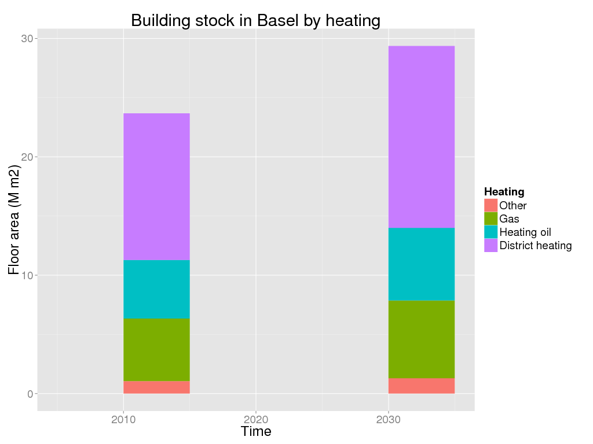
Figure 6. Building stock in Basel by heating type.
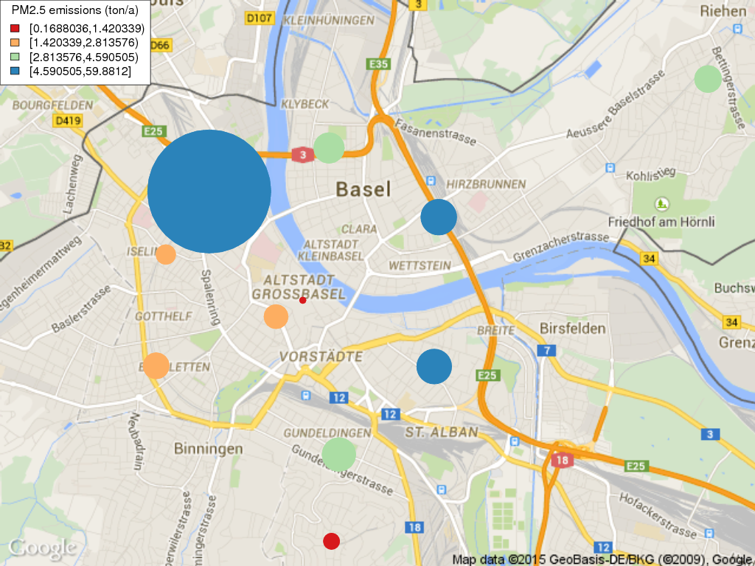
Figure 7. PM_{2.5} emissions from heating in Basel by postal code areas. The emissions of district heating are located to the site of the power plant. Both the size of the sphere and the colour indicate the amount of emission.
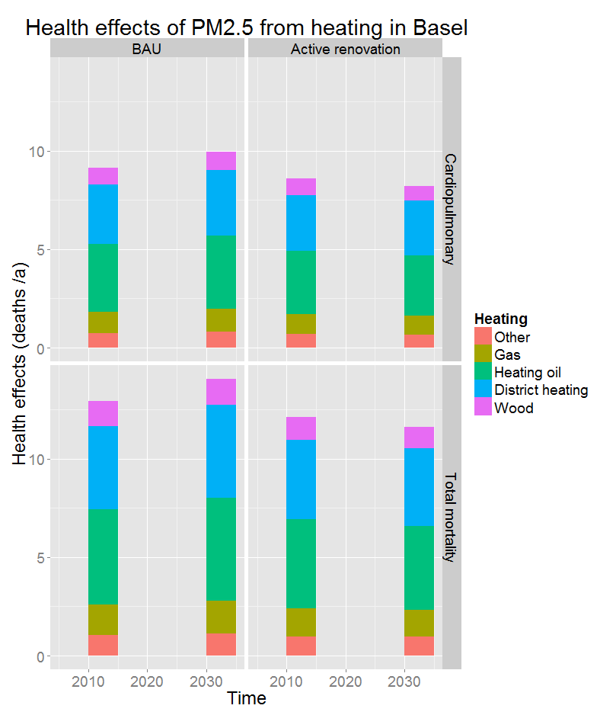
Figure 8. Health effects of heating in Basel by renovation policy.

Discussion
The seven cities participating to the URGENCHE project varied vastly in their size, geographical location, climate conditions, income etc. Only Kuopio, Basel and Thessaloniki assessed climate policies targeted on buildings, but also Rotterdam and Suzhou indicated that some of their GHG mitigation policies are related to energy efficiency and sources of heat for the buildings. Rotterdam relies on the Dutch national program for insulating buildings and a large proportion of the buildings are switching from natural gas to waste heat from industrial sources and in Suzhou all new buildings in year 2050 should be "green", ie. heated by renewable energy. The proportion of energy used in buildings varies between cites from dominant (Kuopio 35% of the total energy use) to marginal (5% in the heavily industrial harbour city of Rotterdam, and even less in Suzhou), thus minimising the relative GHG and ambient air quality potentials of building related policies in some cities. The absolute impact, however, can be equally significant in both ends of the range.
Of the URGENCHE cities Kuopio and Basel provided detailed data on city's building stock. Therefore, the actual modeling was tested for these two cities. However, the developed urban building stock model can be used for a city even if there is only aggregate data available. The assessed policies - not the model - determine how detailed data are needed for useful calculations.
In Kuopio the assessment focused at fuel change from peat to biomass and buildings renovation (30-100 kWh/year reduction per renovated m²). The first demonstrates that replacing half of the peat, a fossil fuel, with wood in district heat and power cogeneration would, from 2000 to 2050, decrease the currently regulated fossil CO₂ emission by half but the total CO₂ emission only marginally. The BAU renovation of 3% of the building stock per year would reduce the total heat demand by 20%, and an enhanced active renovation policy (4.5%/year) would double this reduction. Implemented together, the policies’ impact would be multiplicative.
In Basel 80% of all energy and 100% of electric power is generated from renewable sources. I.e. the building stock causes only marginal fossil CO₂ emissions. Therefore, only the energy conservation impacts of the renovation (15-60 kWh/a reduction per renovated m²) of 1% of the pre 1980 building stock per year in BAU, and 2%/year in the policy scenario were considered.
The assessed local public health benefits of the fuel change and energy conservation – buildings renovation – policies, compared to the BAU, are quite marginal, in the order of 0.1 DALY/year in Kuopio and 10 DALY/year in Basel. The lack of more dramatic results is to be expected first because the thorough energy renovation of the building stock faces a huge inertia, and secondly because the increased energy efficiency of the renovated buildings will have to balance the increasing building stock. These estimates also underestimate the true policy impacts, because most of the particulate exposures and health impacts from the Kuopio CHP plants are felt outside of the municipality limits, and the renovation policy analysis does not assess the impacts on indoor environments. In addition, secondary wood heating in detached houses is a major source of PM_{2.5} in Kuopio even if it is not estimated here. There is an increasing trend to use wood in small scale combustion. This needs further scrutiny.
Concerning the other participating cities, in Stuttgart small scale wood pellet combustion for residential heating generates only 1% of the required heat, but from 2010 to 2025 the burden of disease could be decreased via its banning in the city centre by 15 DALY/year or be increased by its current growing trend by 200 DALY/year. In Thessaloniki the ongoing economic crisis is on one hand forcing the population to conserve energy, but on the other, to replace natural gas, oil and electricity with cheaper fuels, wood and coal. The overall impact is a significant decrease in urban air quality. ^{[5]}
Rotterdam has an exceptional level of energy intensive industry, and the role of buildings in the total energy consumption is only 5%, similar to the two participating Chinese cities. In Suzhou and Xi’an the total energy demand and CO₂ emissions are still rapidly increasing. The building stocks of the two cities, residential in particular, consume only marginal proportions of the total energy, which is dominated by industry. Respectively the energy conservation and GHG mitigation potentials of building policies are small. In Suzhou – one of the most advanced, modern and affluent cities of China – the role of buildings appears to be marginal also for local air pollution. In Xi’an, on the other hand, widespread small scale combustion of coke briquettes and coal for residential heating and cooking and the needs of various small businesses appears to be a key factor in the very high ambient air pollution levels, and, thus, cause of public health risks.
Indoor environmental quality is a critical issue when considering health effects of indoor environments. The realism and even desirability of drastic building renovation policies raises questions. Very ambitious and schematic insulation and air exchange renovations with insufficient consideration of the energy and moisture physics of the different old individual buildings have caused material damage to many buildings and health problems to their occupants in the past. Unfortunately, the model does not yet include indoor air quality aspects. However, thermal comfort in houses of Kuopio was evaluated separately by a questionnaire and a qualitative assessment. This evaluation indicated that thermal comfort is a relevant issue in the current building stock of Kuopio. A part of the residences are too cold in the winter and [a bigger part?] too warm in the summer. Increased insulation required by the energy efficiency regulation could, for many, improve comfort in the winter but, without improved air exchange, decrease the thermal comfort during the summer.
In conclusion, we were able to develop an online model that fulfils its objectives and is capable of producing useful guidance on practical policy questions on city level. Although the model is openly available, it requires specific computing skills to adapt it to a new city and thus the current version hardly becomes an everyday tool in cities. However, it offers the core functionalities that can be enhanced with better user interfaces for wider use.

Data and Software Availability
All data and software are published and available in Opasnet (http://en.opasnet.org/Building_model) with Creative Commons Attribute - Share alike 3.0 license.

Author Contributions
CS, MJ, NK, and JT conceived the study. JT, MN, and MJ designed the building model. AA, EP, LP, ST, and MN collected the city-specific and generic data needed in the model. JT wrote the model code. MN, AA, and MJ wrote the first draft of the manuscript. JT, AA, and MJ wrote the final manuscript. All authors were involved in the revision of the draft manuscript and have agreed to the final content.

Competing interests
No competing interests were disclosed.

Grant information
URGENCHE was funded by EU FP7 contract no 265114.

Acknowledgments

Supplementary matrial
- Supplementary material 1: Summaries of input data used in the model
- Supplementary material 2: Model run for Kuopio
- Supplementary material 3: Model run for Basel

References
- IEA: Energy Balances of OECD Countries. OECD/IEA 2011, Paris, 330 pp.
- Hänninen O, Asikainen A (eds.), (2013). Efficient reduction of indoor exposures: Health benefits from optimizing ventilation, filtration and indoor source controls. National Institute for Health and Welfare (THL). Report 2/2013. 92 pages. Helsinki 2013. ISBN 978-952-245-821-6 (printed) ISBN 978-952-245-822-3 (online publication) http://urn.fi/URN:ISBN:978-952-245-822-3
- Pöyry Finland Oy (2011). Kuopion kasvihuonekaasupäästöjen vähentämismahdollisuudet 2020 mennessä (report in Finnish only).
- Perez 2011.
- Sarigiannis D, Karakitsios SP, Kermenidou M, Nikolaki S, Zikopoulos D, Semelidis S, Papagiannakis A, Tzimou R. (2014). Total exposure to airborne particulate matter in cities: the effect of biomass combustion. Sci Total Environ. 795-805. doi: 10.1016/j.scitotenv.2014.06.055.

Figures and Tables
Figure 1. Conceptual model of important factors related to city-level energy balance and buildings. This conceptual model was used to develop the actual computational model focussing on buildings. Driving forces are in pink, outcomes of interest in orange, and decisions to change outcomes in red.

Figure 2. The actual modules of the computational model. The upstream modules contain city-specific building data, and the model becomes increasingly generic in the downstream. Health impact module is actually another generic Opasnet model that is compatible with the building model and uses its outputs as inputs.

Figure 3. Building stock in Kuopio by heating type.

Figure 4. Heating energy used in Kuopio by heating type and renovation policy. Left panel is business as usual (3%/a renovations), middle panel is active renovation (4.5 %/a renovations), and right panel is efficient renovation (3 %/a, sheath reform to all).

Figure 5. Emissions from heating in Kuopio by fuel type: estimated history and predictions 1920-2050. Left panels are for BAU, right panels are for biofuel policy. CO₂ official (middle horizontal panel) assumes that biofuel emissions are carbon neutral. Secondary wood heating is missing from the estimates although it is a substantial proportion of the current exposure.

Figure 6. Building stock in Basel by heating type.

Figure 7. PM_{2.5} emissions from heating in Basel by postal code areas. The emissions of district heating are located to the site of the power plant. Both the size of the sphere and the colour indicate the amount of emission.

Figure 8. Health effects of heating in Basel by renovation policy.

Table 1. Basic description of URGENCHE cities.
City | Population | Population density / km2 | Area (km2) | Annual mean temperature (7) | Total annual precipitation (7) | GHG emissions Mt CO₂-eq | Life expectancy  male/female
Basel | 192 000 | 7 564 | 23.9 | 9.5 | 784 | 2.4 | 76.1 / 81.6
Kuopio | 105 000 | 46 | 3165.0 | 2.7 | 498 | 1.02 | 76.7 / 83.2 (3
Rotterdam | 550 000 | 2 952 | 325.8 | 10.4 | 856 | 32.6 | 75.7 / 81.2
Stuttgart | 590 000 | 2 958 | 207.4 | 9.6 | 689 | 5.1 | 78 / 83 (4)
Suzhou | 10.6 million (urban 5.5 million) | 1 200 (urban 2 000) | 8 488 (urban 2 743) | 17.02 | 932 | 181 | 74 / 77 (5)
Thessaloniki | 1.1 million (urban 790 000) | 692 (urban 7 080) | 1 456 (urban 112) | 15.6 | 458 |  | 78 / 84 (6)
Xi’an | 8.5 million (urban 6.5 million) | 850 (urban 7 900) | 9 983 (urban 826) | average high 19.3, average low 9.2 | 553 | road traffic 15 (2) | 73.3 / 78.3
(1) Wikipedia 5.5-10.5 million, (2) total not available, (3) Terveyskirjasto (www.terveyskirjasto.fi), (4) WHO 2011 Germany (www.who.int/gho/database/en), (5) WHO 2011 China, (6) WHO 2011 Greece (7) Source for Basel, Kuopio, Stuttgart, Thessaloniki: climatemps.com; source for Rotterdam, Suzhou, Xi´an: wikipedia

Table 2. Studied climate policies of Kuopio and Basel and business as usual (BAU) scenarios.
City | Renovation BAU | Active renovation | Efficient / Total renovation | Fuel BAU | Fuel policy
Kuopio | 3 % of buildings renovated per year | 4.5% of buildings energy-renovated per year | 3 % per year renovated, sheath reform to all | 84 % peat, 12 % heavy oil and 4 % biomass in Haapaniemi plant | 49% peat, 50 % wood biomass and 1 % heavy oil in Haapaniemi plant
Basel | 1% of residential buildings <1980 renovated per year | 2% of buildings <1980 renovated per year | Any residential building built before 1980 renovated | - | -

Table 3. Comparison of the health impacts of selected policies in Kuopio and Basel (DALY/a)
Time | Renovation policy | Fuel policy | Kuopio | Basel
2010 | BAU | BAU | 47 | 140
2010 | BAU | Biofuel increase | 47 | 140
2010 | Active renovation | BAU | 45 | 130
2010 | Active renovation | Biofuel increase | 45 | 130
2010 | Effective renovation | BAU | 44
2010 | Effective renovation | Biofuel increase | 44
2030 | BAU | BAU | 36 | 160
2030 | BAU | Biofuel increase | 35 | 160
2030 | Active renovation | BAU | 32 | 130
2030 | Active renovation | Biofuel increase | 31 | 130
2030 | Effective renovation | BAU | 28
2030 | Effective renovation | Biofuel increase | 27

